**The different level between of accident between Night and Day**

The pie chart shows the percentage of accident during the Day and the Night, and also the bar chart shows the level of both times. The also mean that, there are more accident in the Day time than Night time.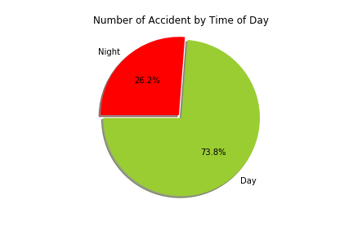

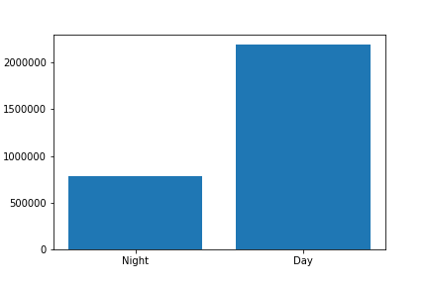

**Number of accidents per hour throughout the Day and Night**

It shows on the graph how many accidents happen in day time and night. The chart also shows the time when accident happen the most.

